1. **Agenda:**
   1. Structure of each packet.
2. 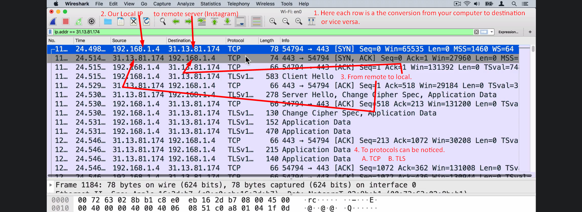
3. 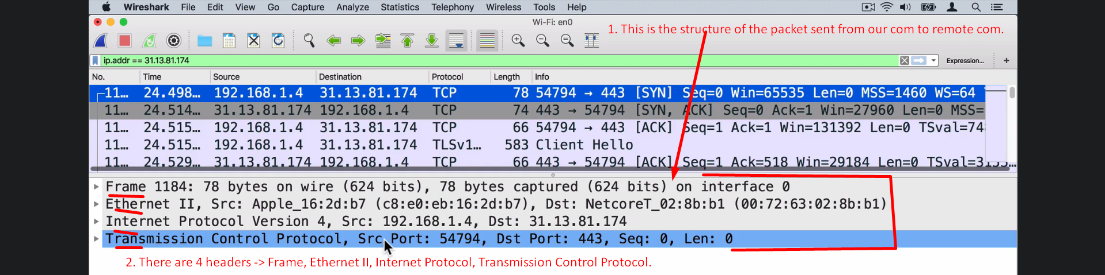
4. 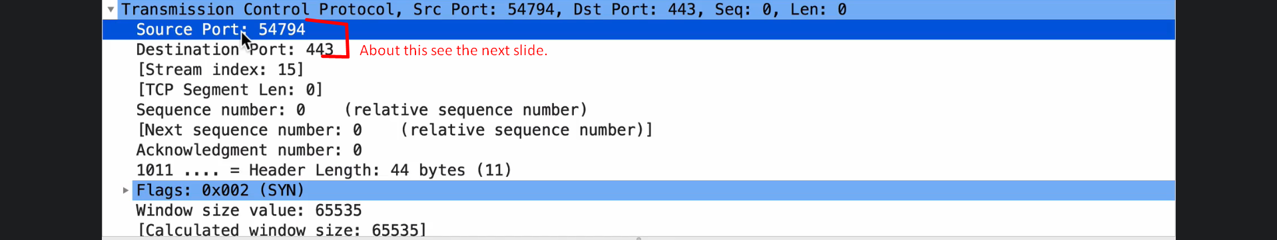  
   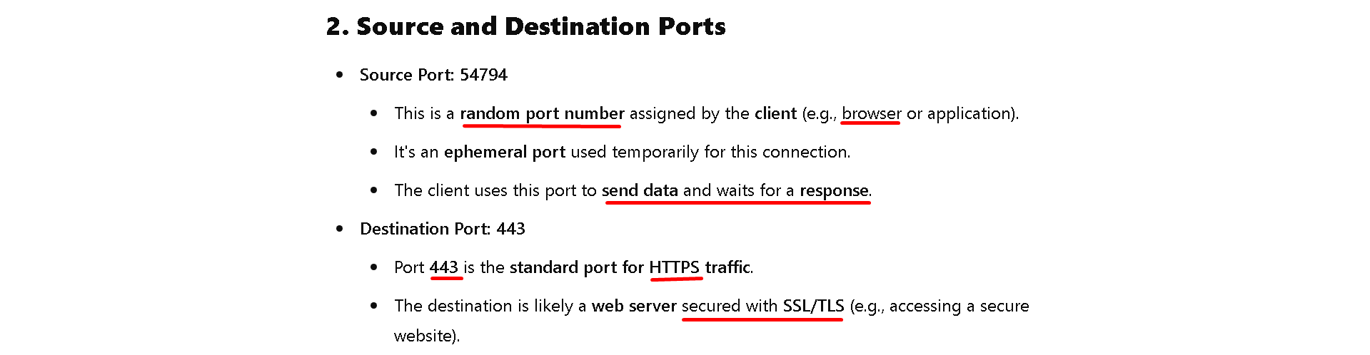  
   The point is that the client has sent request to PORT 443 which is for HTTPS.
5. 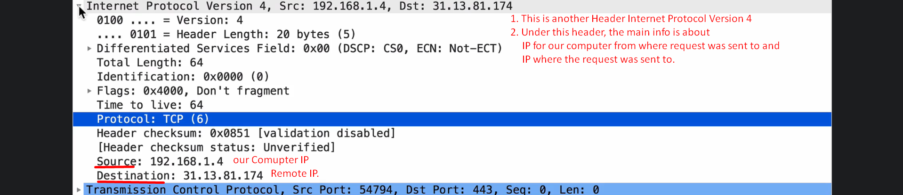  
   so basically, IPV4 header is used for routing each packet as it contains IP addresses.
6. 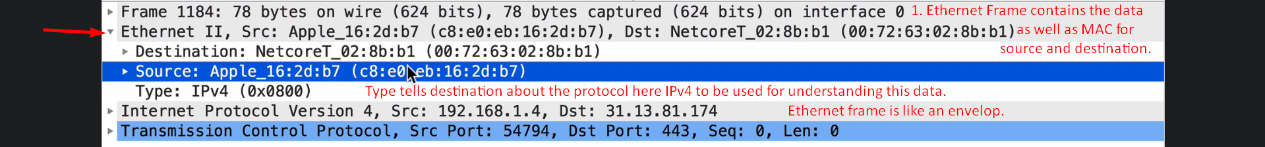
7. 